1. **Your bank is offering you an account that will pay 18 % interest in total for a​ two-year deposit. Determine the equivalent discount rate for a period length​ of**

**a. Six months.**

**b. One year.**

**c. One month.**

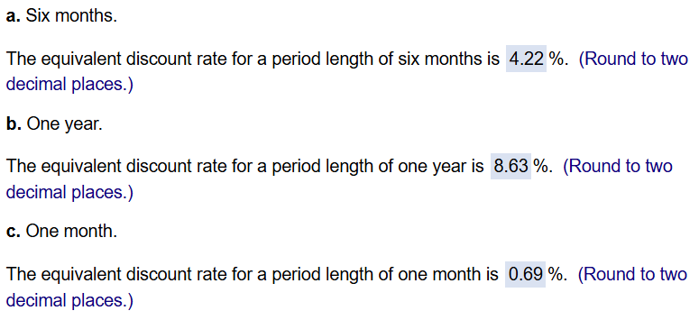

1. **You have found three investment choices for a 1​-year ​deposit: 5 % APR compounded​ monthly, 5 % APR compounded​ annually, and 4 % APR compounded daily. Compute the EAR for each investment choice.​ (Assume that there are 365 days in the​ year.)**
2. **For the case of 5 % APR compounded​ monthly, the EAR is ____ ?**
3. **For the case of 5 % APR compounded​ annually, the EAR is ____ ?**
4. **For the case of 4 % APR compounded​ daily, the EAR is ____ ?**

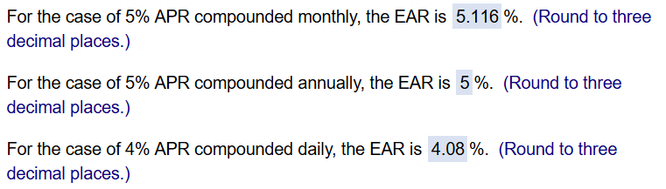

1. **You are considering moving your money to a new bank offering a​ one-year CD that pays an APR of 6% with monthly compounding. Your current​ bank's manager offers to match the rate you have been offered. The account at your current bank would pay interest every 6 months. How much interest will you need to earn every 6 months to match the​ CD?**

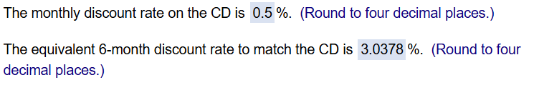

1. **You can earn ​$35 in interest on a ​$1,000 deposit for 8 months. If the EAR is the same regardless of the length of the​ investment, how much interest will you earn on a ​$1,000 deposit​ for:**

**a. 10 months.**

**b. 1 year.**

**c. 1.1 years.**

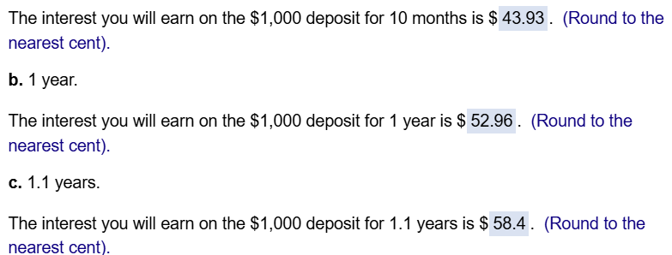

1. **Capital One is advertising a 60​-month, 5.64 % APR motorcycle loan. If you need to borrow ​$7,000 to purchase your dream Harley​ Davidson, what will your monthly payment​ be?**



1. **You have decided to refinance your mortgage. You plan to borrow whatever is outstanding on your current mortgage. The current monthly payment is ​$2,633.61 and you have made every payment on time. The original term of the mortgage was 30 ​years, and the mortgage is exactly four years and eight months old. You have just made your monthly payment. The mortgage interest rate is 6.369 % ​(APR). How much do you owe on the mortgage​ today?**

** GPT**

1. **The mortgage on your house is 5 years old. It required monthly payments of ​$1,402​, had an original term of 30 ​years, and had an interest rate of 10 % ​(APR). In the intervening 5 ​years, interest rates have fallen and so you have decided to refinancelong dashthat ​is, you will roll over the outstanding balance into a new mortgage. The new mortgage has a 30​-year ​term, requires monthly​ payments, and has an interest rate of 6.625 % ​(APR).**

**a. What monthly repayments will be required with the new​ loan?**

**b. If you still want to pay off the mortgage in 25 ​years, what monthly payment should you make after you​ refinance?**

**c. Suppose you are willing to continue making monthly payments of ​$1,402. How long will it take you to pay off the mortgage after​ refinancing?**

**d. Suppose you are willing to continue making monthly payments of ​$1,402 and want to pay off the mortgage in 25 years. How much additional cash can you borrow today as part of the​ refinancing?**

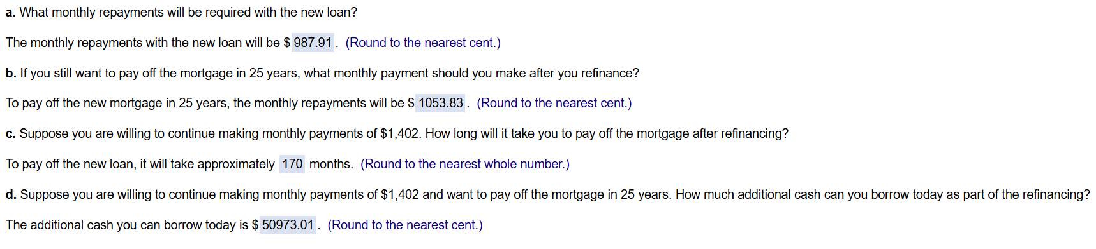

1. **If the rate of inflation is 5.58 %​, what nominal interest rate is necessary for you to earn a 3.36 % real interest rate on your​ investment?**



1. **Your newborn daughter has received a total of​ $2,500 in cash from various friends and relatives. If you deposit this money for her in an investment that returns an average return of​ 12% a​ year, how much will she have accumulated on her 21st​ birthday, to the nearest​ dollar?**

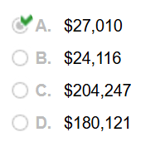

1. **If​ $100 is deposited into an account that earns a quoted rate of​ 16%, compounded​ quarterly, for five​ years, how much will be in the account at the end of the 5th​ year? Round your answer to the nearest dollar.**

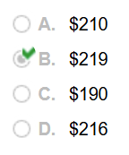

1. **In which of the following accounts would you prefer to invest your​ money?**

**A. one that pays​ 4.5%, compounded annually**

**B. one that pays​ 4.75%, compounded quarterly**

**C. one that pays​ 4.25%, compounded monthly**

**D. one that pays​ 4%, compounded daily**

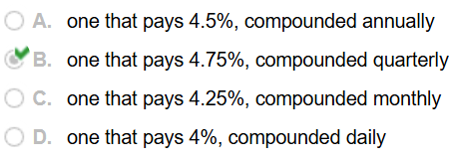

1. **A gallon of gasoline cost​ $0.39 during the summer of 1968 and​ $3.50 in the summer of 2008. To the nearest tenth of a​ percent, this is an average annual increase of**

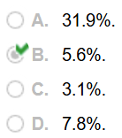

1. **The Monumental Returns Investment Company is offering you an investment that promises you​ $1,000 at the end of ten years if you invest​ $500 today. What average annual rate of return does this investment​ promise? Round your answer to the nearest tenth of a percent.**

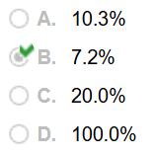

1. **How much must you deposit in a bank account today to have​ $1,000 at the end of 5 years if the bank quotes a rate of​ 5%, compounded​ daily? Assume a 365minusday year and round your answer to the nearest dollar.**

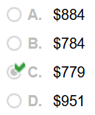

1. **You purchased a zerominuscoupon bond last week for​ $499. The bond promised to pay​ $1,000 in ten years. Since your​ purchase, prevailing interest rates have increased by 50 basis points. If you assume no other changes have occurred that would affect your​ bond's price, which of the following statements is necessarily​ true?**

**A. The value of your investment has decreased to about​ $476.**

**B. The value of your investment has increased to about​ $549.**

**C. The value of your investment has decreased to about​ $449.**

**D. The value of your investment has stayed the same since this is a zerominuscoupon bond.**

